Big Mountain Resort Report

To offset the increased operating costs of the new chair lift, Big Mountain resort can increase their Adult Weekend Lift ticket price to $93.56. This lift ticket price was determined by comparing Big Mountain’s features to other resorts in North America. Big Mountain resort has a large skiable acreage, high yearly snowfall, and high vertical elevation compared to other resorts. These attributes correlate well with increased lift ticket prices. The figures below highlight where Big Mountain Resort fits currently in comparison with other resorts.

The below figure illustrates that resorts with a large amount of skiable area can generally charge more for lift tickets.

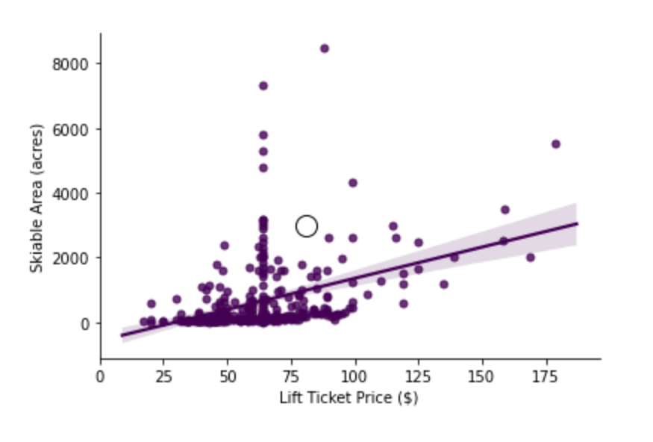

The below figure illustrates that resorts that stay open for more days can charge more for lift tickets.

